PL SQL TASK

create table emp (

emp_id numeric primary key,

emp_name varchar(50),

dep_id numeric,

constraint fk_dept foreign key (dep_id) references department(department_id)

);

ALTER TABLE emp

ADD salary numeric;

create table department(

department_id numeric primary key,

dept_name varchar(50),

emp_count numeric

);

insert into emp values(105 , 'sedhu', 2);

insert into emp values(108, 'savitha', 3, 'pune', 28000, '2020-02-01');

update emp set salary= 25000 where emp_id=103;

alter table emp

add doj date;

update emp set doj= '2021-10-11' where emp_id=105;

insert into department values(3,'TN',0);

1. Create a trigger that display the count of rows after inserting a new record to a product

Before inserting:

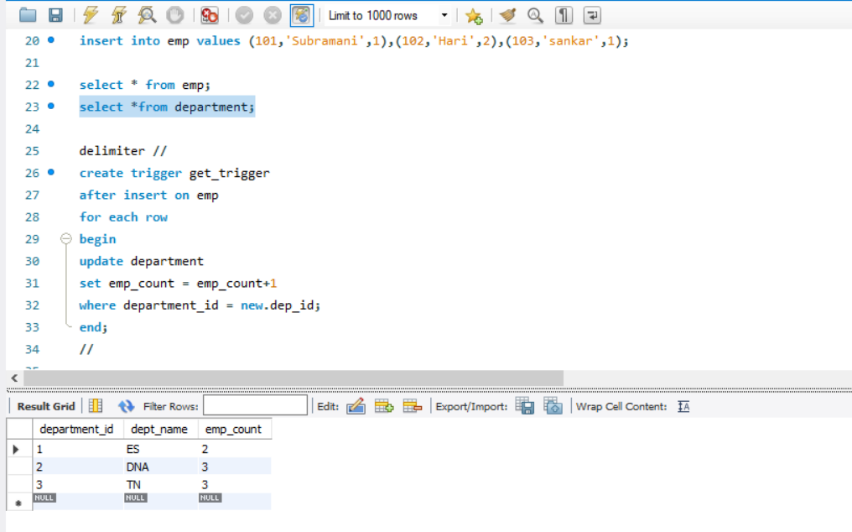

While inserting: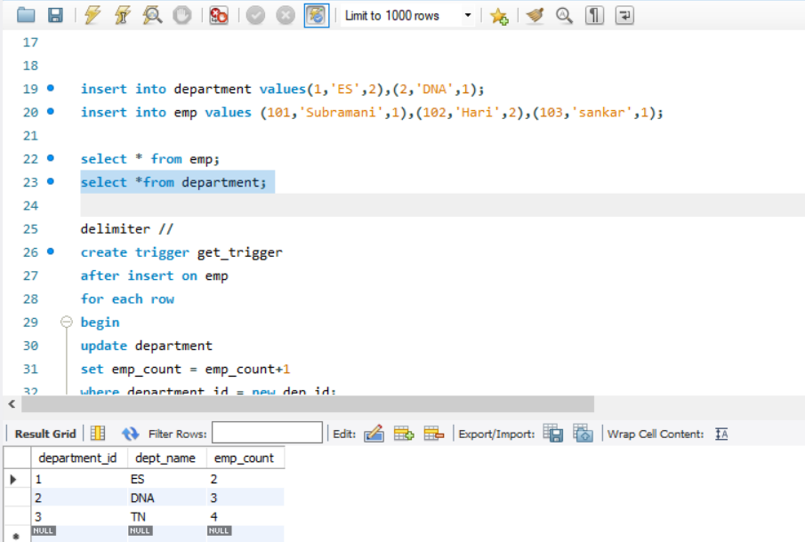

After inserting:

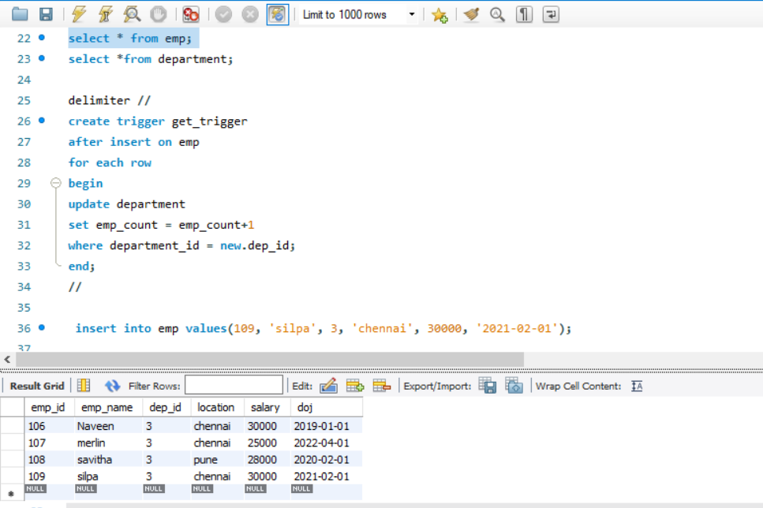

2.Create a View those who all are in Chennai and TN department

create view getemployeedetailsinChennai as

select * from emp

join department on emp.dep_id = department.department_id

where emp.location = 'chennai' and department.dept_name= 'TN';

select * from getemployeedetailsinChennai;

